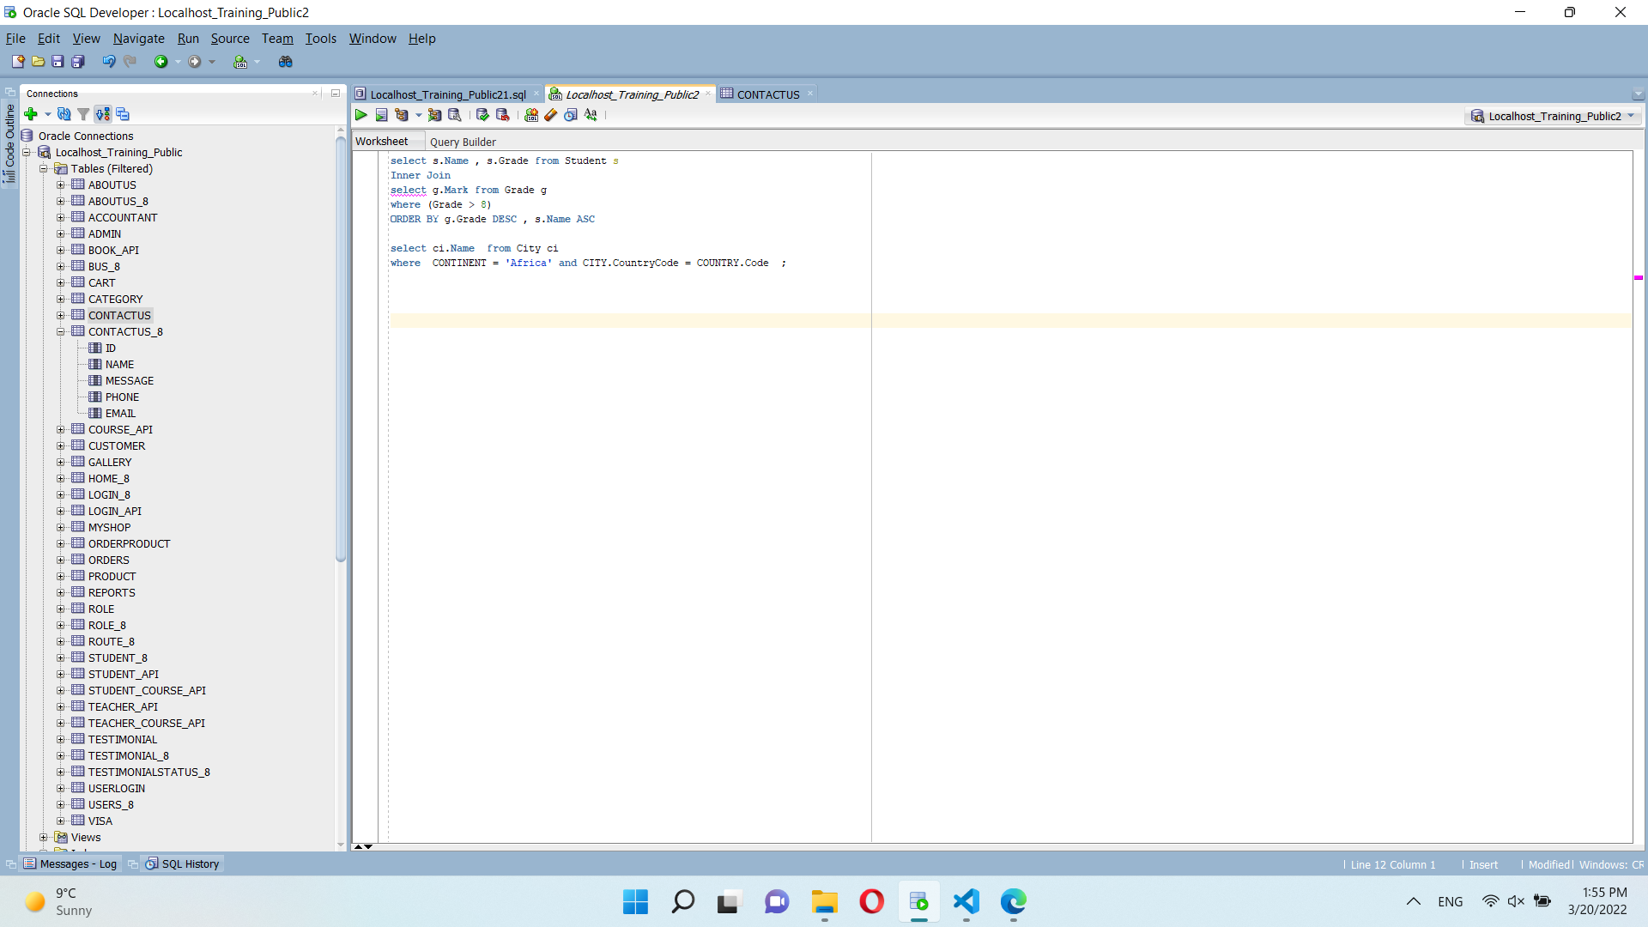



**class** exam {

**static** **int** SIZE = 26;

**static** **void** characters (String str)

    {

**int** n = str.Length;

**int**[] arr = **new** **int**[SIZE];

**for** (**int** i = 0; i < n; i++)

            arr[str[i] - 'a']++;

**for** (**int** i = 0; i < n; i++) {

**if** (arr[str[i] - 'a'] != 0) {

                Console.Write(str[i]);

                Console.Write(arr[str[i] - 'a'] + " ");

                arr[str[i] - 'a'] = 0;

            }

        }

    }

**public** **static** **void** Main()

    {

        String str = "aabbbccde";

        characters(str);

    }

}